Project Overview
The Uber Trip Analysis Dashboard is an interactive business intelligence solution developed in Power BI to analyze Uber trip data. The objective of this project is to transform raw trip records into meaningful business insights that help understand customer behavior, booking patterns, revenue generation, and operational performance.
This dashboard enables users to monitor key performance indicators (KPIs), identify booking trends, evaluate trip distances, analyze payment methods, and assess booking statuses through interactive visualizations.

Objectives
- Analyze Uber booking trends.
- Monitor total bookings and revenue.
- Understand customer travel patterns.
- Evaluate trip distances and durations.
- Analyze booking status.
- Study payment method distribution.
- Build an interactive dashboard using Power BI.

Tools Used
Tool | Purpose
Microsoft Excel | Data Source
Power BI | Dashboard Development
Power Query | Data Cleaning
DAX | Calculated Measures
GitHub | Version Control

Data Preparation
The dataset was cleaned using Power Query by:
- Removing duplicate records
- Handling missing values
- Formatting date and time columns
- Creating calculated columns
- Preparing data model relationships

Key Performance Indicators
- Total Bookings
- Total Revenue
- Average Booking Value
- Average Trip Distance
- Average Trip Time
- Cancellation Rate

Dashboard Pages

1. Overview Dashboard
Displays overall business performance using KPIs and summary charts.
Features:
- Total Bookings
- Total Revenue
- Average Trip Distance
- Booking Trend
- Revenue Trend

2. Trip Analysis
Provides insights into customer travel behavior.
Includes:
- Trip Distance Analysis
- Vehicle Type Comparison
- Pickup and Drop-off Analysis
- Trip Duration Analysis

3. Booking Analysis

Analyzes booking performance.
Includes:
- Successful Bookings
- Cancelled Bookings
- Booking Status Distribution
- Payment Method Analysis

DAX Measures Used
Examples include:
- Total Bookings
- Total Revenue
- Average Trip Distance
- Average Trip Duration
- Cancellation Percentage

Business Insights
- Peak booking periods can be identified for better resource planning.
- Revenue trends help evaluate business performance.
- Popular payment methods indicate customer preferences.
- Vehicle-wise analysis supports fleet optimization.
- Booking status analysis highlights cancellation patterns.

Skills Demonstrated
- Data Cleaning
- Data Modeling
- Power Query
- DAX
- Interactive Dashboard Design
- KPI Development
- Business Analysis
- Data Visualization

Conclusion
The Uber Trip Analysis Dashboard successfully converts raw operational data into actionable business insights. The project demonstrates proficiency in Power BI, Power Query, DAX, and data visualization while highlighting the ability to design interactive dashboards for business decision-making.

Home page:

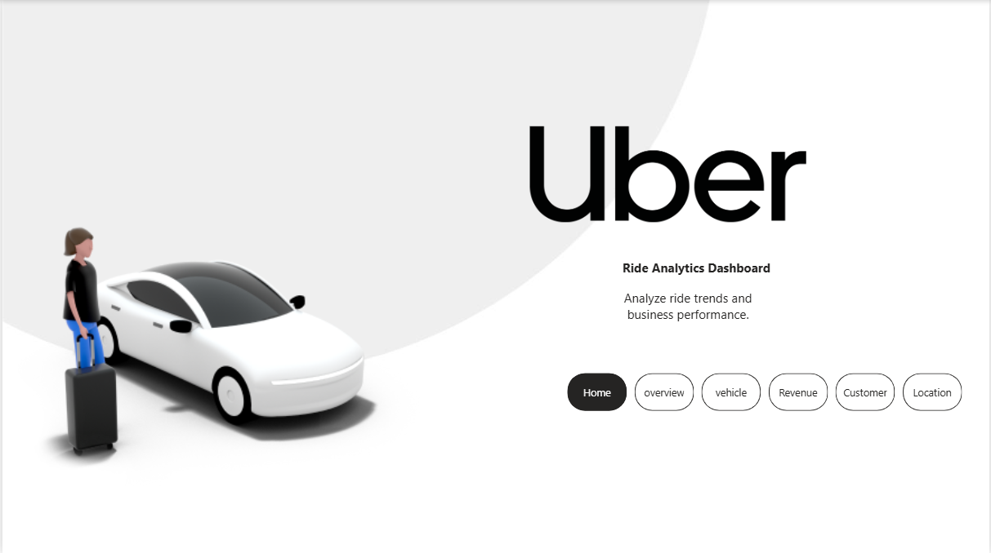

Overview page:

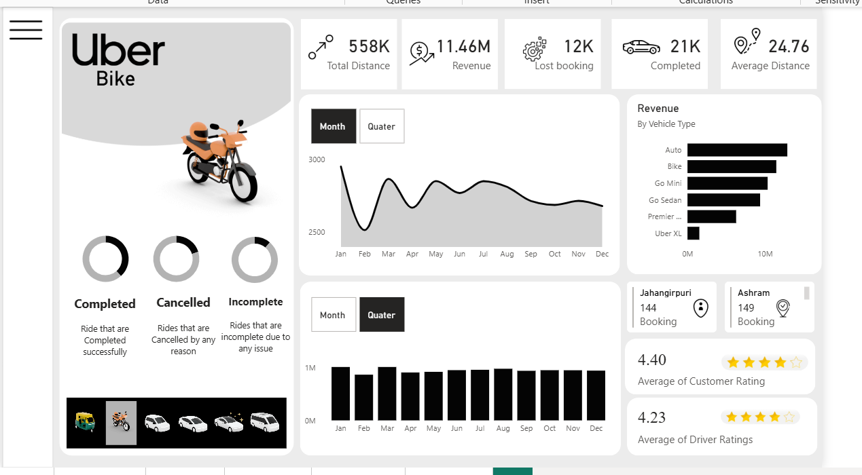

Customer:

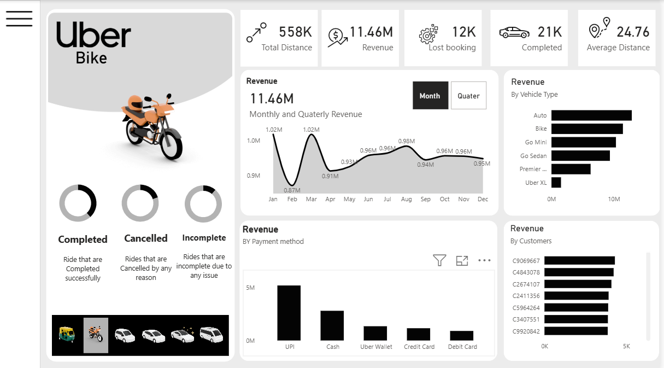
vehicle:

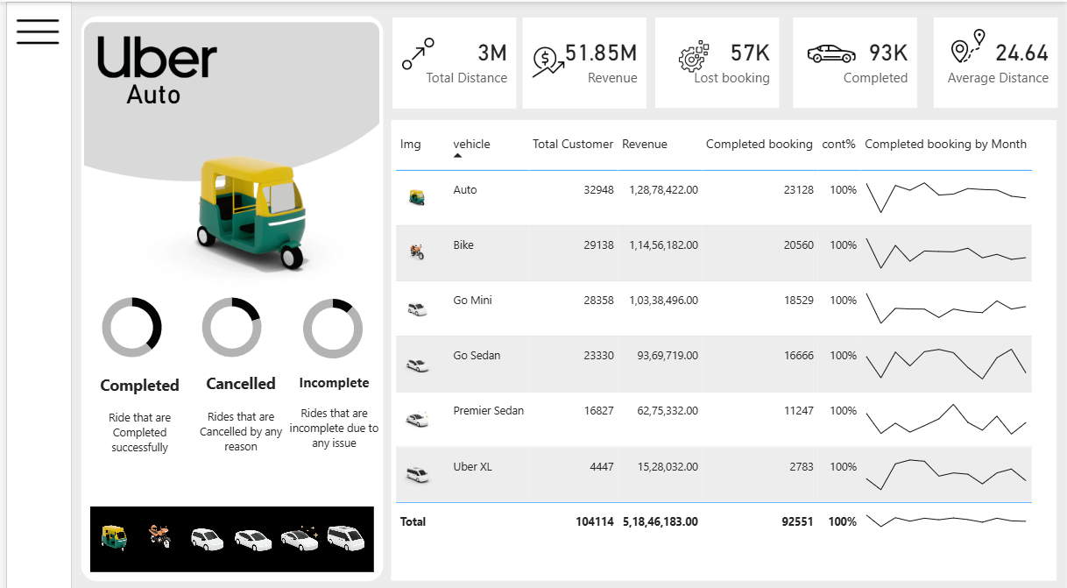

Location:

